4

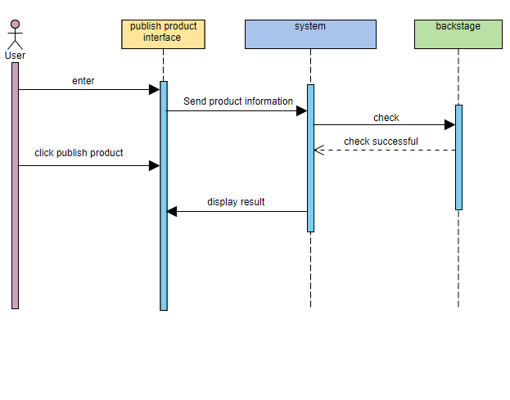

The user enters the publish product interface and sends a publish request to the system. The user clicks to post the product, the product information is uploaded to the system, and the background administrator performs check. Check passed, display the results and feed back to the user

5

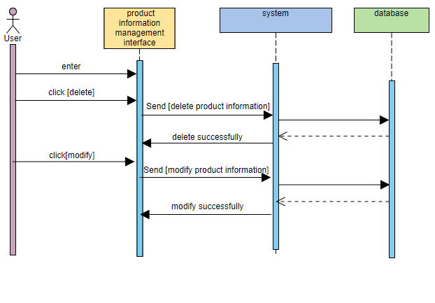

The user enters the product management interface, selects the deleted product and clicks delete. Send the deleted product information to the system, and then query the database. The database feedback information to the system, and finally the product information is deleted successfully. At the same time, we added the function of modifying the product information, and the operation is the same.